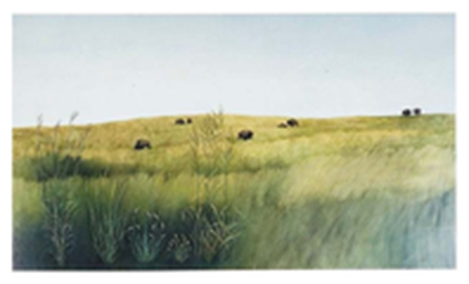 View of prairie with a herd of bison in the background. Also depicted are five insets with details of short grass and tall grass prairie plants (l-r): Big Bluestem, Sideoats Gramma, Blue Gramma, Buffalograss, and Prairie Cordgrass./NPS

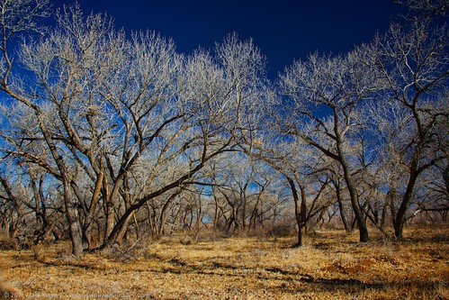 Cottonwood Trees

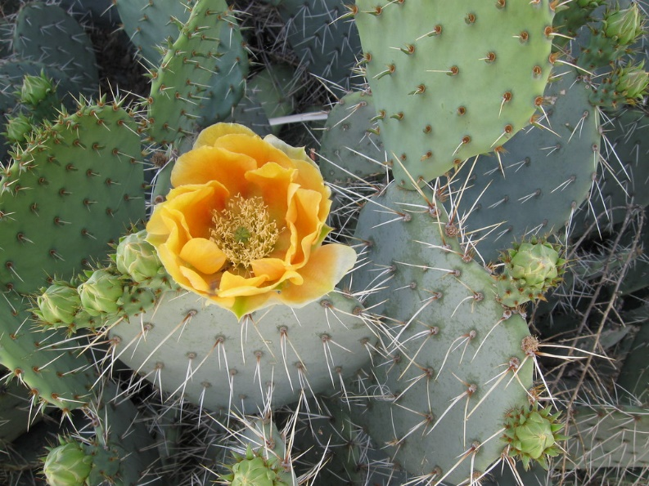 Prickly Pear Cactus

close up photo of pine nuts
 Pine Nuts

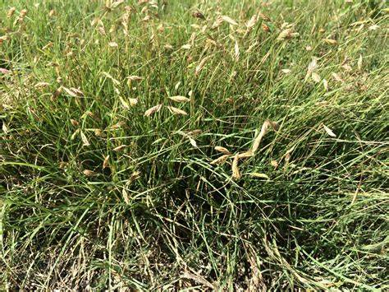 Buffalo Grass

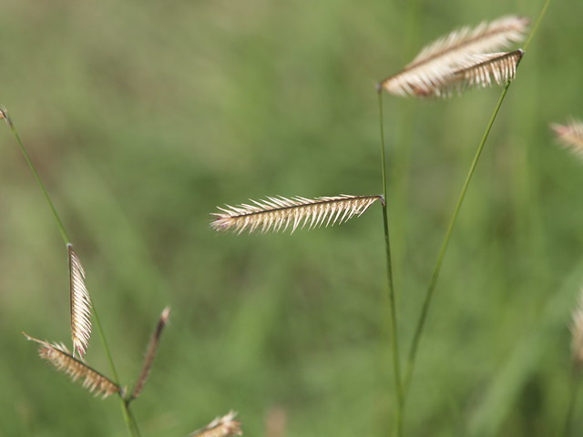 Blue Grama Grass